**Final Project: 311 Call Center Tracking Data for City of Los Angeles**

DSO 545: Statistical Computing and Data Visualization

Fall 2016

Afternoon Section, Group 1:

Chris Anderson, Snigdha Goel, Deepa Rama Hegde, H. Leo Kim, Dzuy Nguyen

**Problem Statement**

The City of Los Angeles would like to analyze the city’s 311 call center and service request tracking data. The purpose of this project was to investigate and understand the trends and patterns of requests relative to time, geography, social, and economic makeup of Los Angeles’ neighborhoods. This will ultimately allow us to understand the needs of the city’s inhabitants, and provide a path as to how the city can make more effective and efficient use of their services and resources.

**Abstract**

The City of Los Angeles’ 311 system acts as a central point for requests for non-emergency city service through a city-wide phone number. Requests to the 311 system can also be made through e-mail, self-service webpage, voicemail, and smartphone apps available for the iOS and Android model operating systems. Every Angeleno can request city services through the 311 system, from graffiti removal to electronic waste removal to illegal dumping pickup.

Our team was provided 2 datasets by the City of Los Angeles’ 311 department: the first dataset consists of call center tracking data and service request data. Generally, the 311 data these service requests product reflect the needs of the city and its inhabitants. Our goal was to analyze the data to make more effective and efficient use of city services and resources.

We wanted to investigate how patterns of call and service requests are related to the time, geography, social, and economic make up of Los Angeles’ neighborhoods. Specifically, we want to answer three key questions:

* What do service requests tell us about the different neighborhoods in Los Angeles?
* How can we use these characteristics to better serve the city’s inhabitants?
* How can we use the analysis of this data to make public services more proactive and responsive?

Our analysis is a preliminary look at understanding cities and optimizing government through the lens of 311. Generally, we have found that the majority of calls to the system are concentrated in the downtown Los Angeles area and the San Fernando valley and come through the 311 phone number. Over 70% of the requests are for the removal of bulk items, household appliances, and electronic waste.

**Methodologies**

Our analysis was comprised of exploratory analysis of how Los Angeles’ neighborhoods interact with the city’s 311 service requests. We used 3 main data sources:

1. The caller center data consists of 311 call center data from years 2011 to 2015
2. The service request data consist of 311 service requests data originating from call center data from 2015 to 2016
3. 2010 U.S. Census data for demographic and economic data

The 311 system data contains call and service request data that was stored in a database, and contains updated information about that request. The 311 datasets contain information on when and where a service is requested, and when such request is filled by the city.

Our exploratory analysis of the datasets is primarily through visualization of time series, scatterplots, and geographical mapping overlays. In addition to analyzing the data using traditional frequencies (day of week, week, month, year), we have also used the quarter system as defined by the City of Los Angeles’ fiscal year reports. The system’s convention is as follows:

* **Q1** – July to September
* **Q2** – October to December
* **Q3** – January to March
* **Q4** – April to June

This project is implemented in the R statistical programming language and associated packages, and used with the RStudio integrated development environment. We used the following R packages to perform data manipulation, statistical analysis, and visualization:

* *stringr*, *lubridate* for conversion of variables as required
* *dplyr* to find calculated fields
* *ggplot2* for visualization

Data cleaning methods used in this project include:

* Deleting duplicates
* Deleting NA values
* More generalized classifications for improving readability

**Analysis and Discussion**

Our first analysis looked at the total 311 call center requests as it pertains to geography and economic and social factors. From the geographical graph below, we can observe that the concentration of calls are primarily concentrated in the downtown area and concentrated to a lesser extent in the San Fernando Valley and in the South Bay in the San Pedro/Long Beach area.

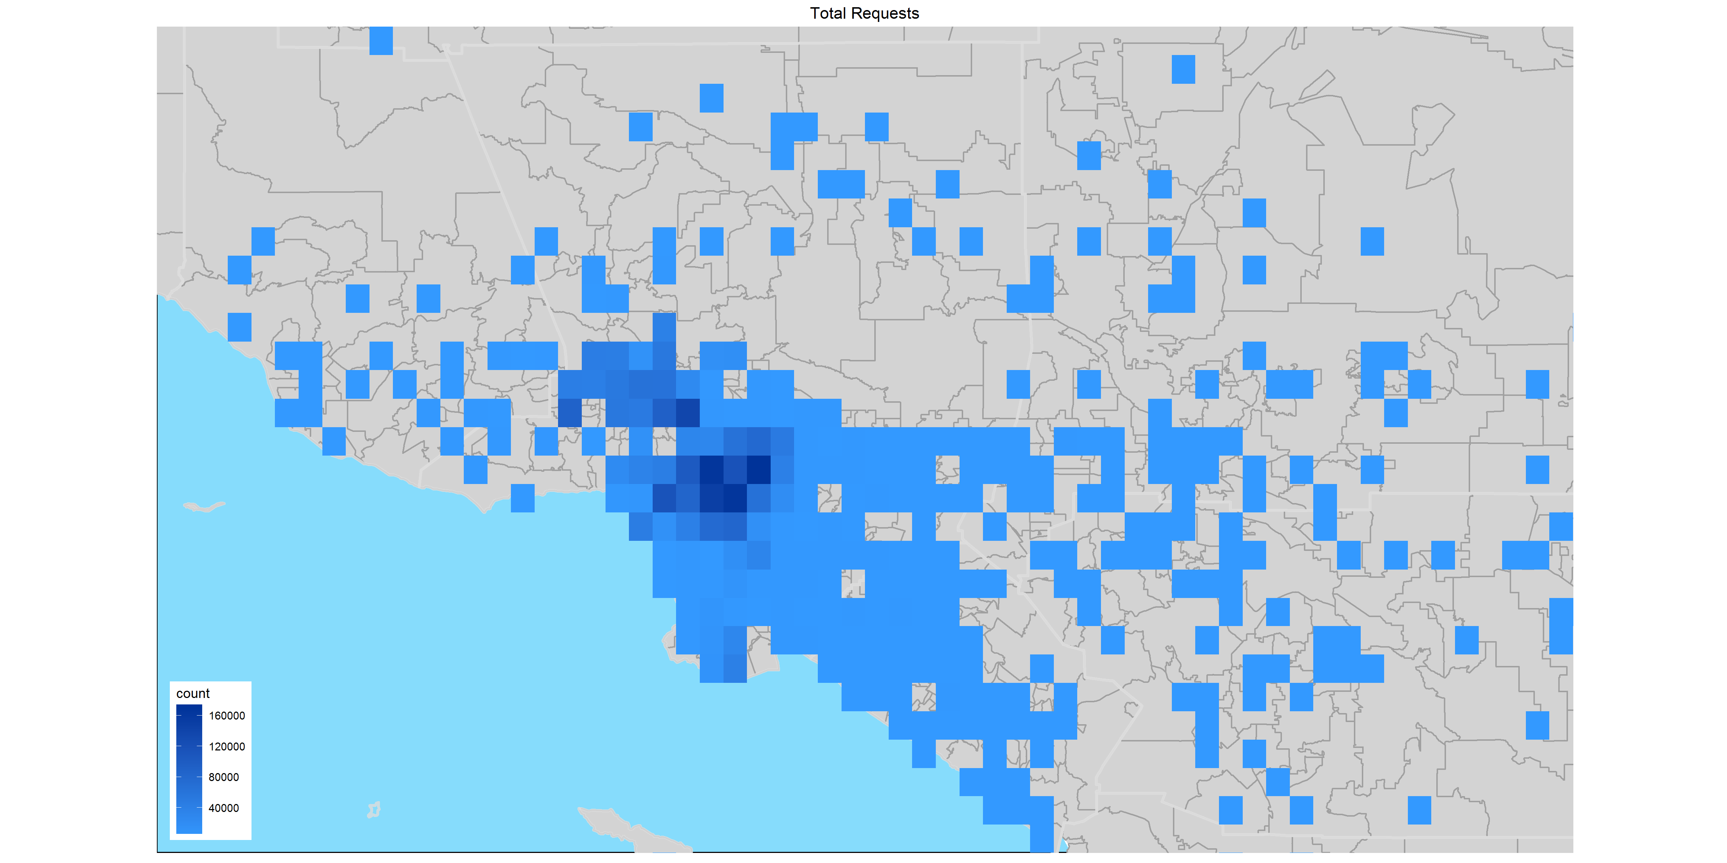

The top zip codes by call frequency is shown below, with the higher number of call originating from 90012. A region that encompasses the northern portion of downtown Los Angeles, Chinatown, and Dodger stadium.

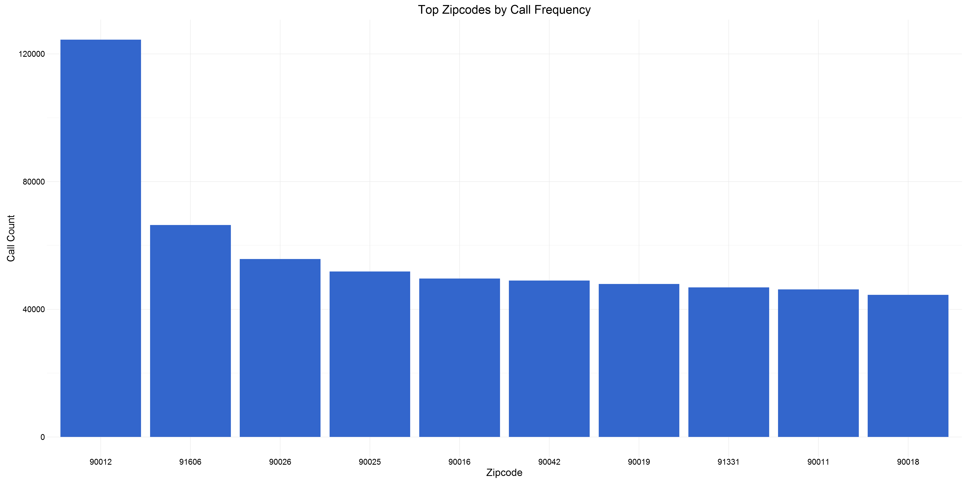

Overlaying U.S. Census demographic and economic data onto the 311 system data, we can observe that the majority of calls originate from zip codes with a median yearly income of approximately $30,000 and $70,000.

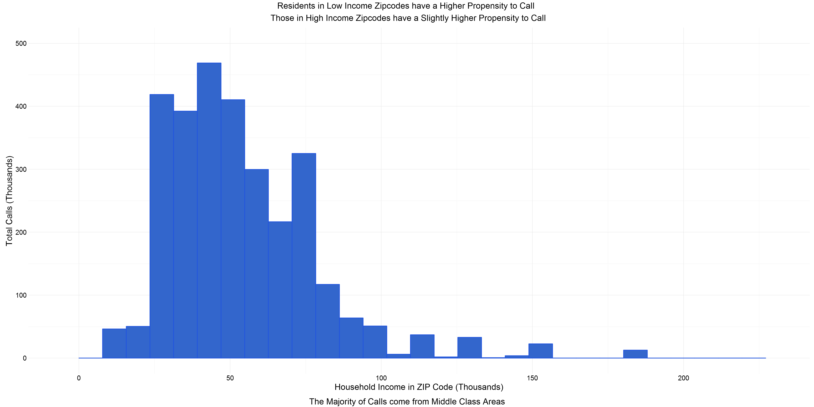

A majority of the callers are originating from zip codes with median home prices of $260,000 and $740,000.

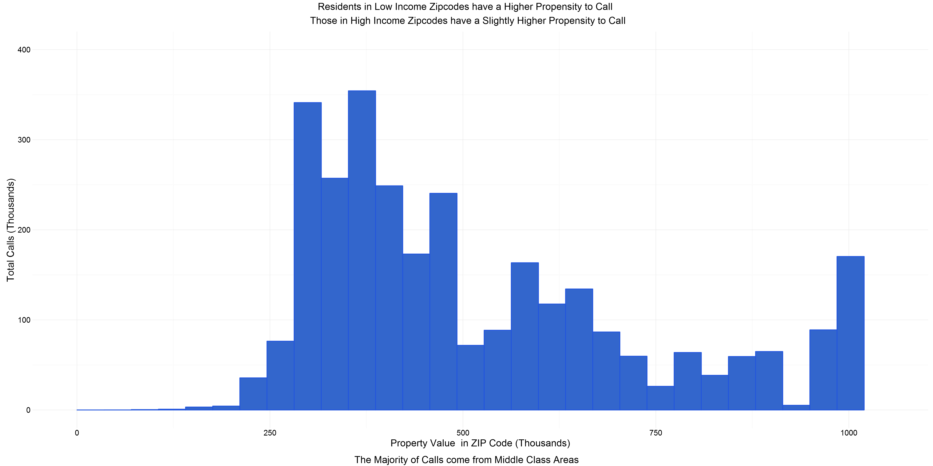

Call are clustered around zip code with approximately 10% of citizens over 65 years old. This implies that a majority of callers are under the age 65 and likely employed.

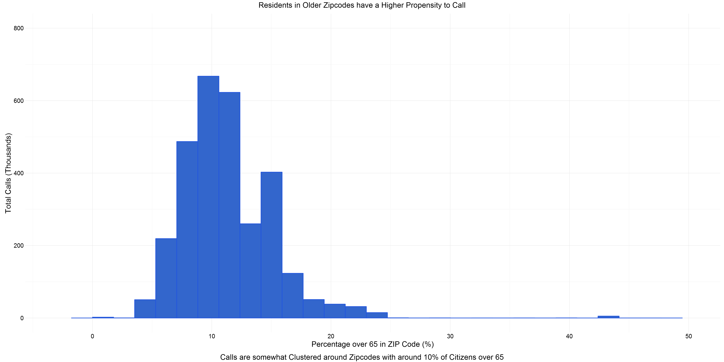

Almost all calls originate from zip codes with 70% or lower of inhabitants with college degree or higher.

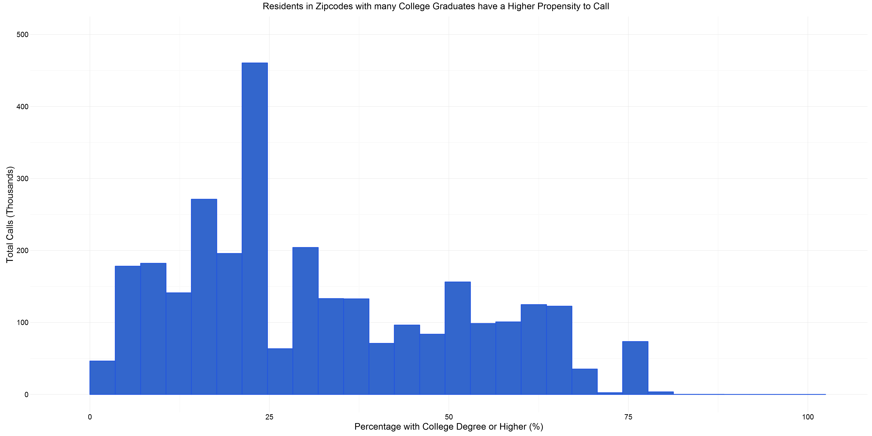

Neighborhoods with more renters are more likely to submit requests to the 311 system. Most of the callers originate from neighborhoods in which renters represent 40% or more of the population.

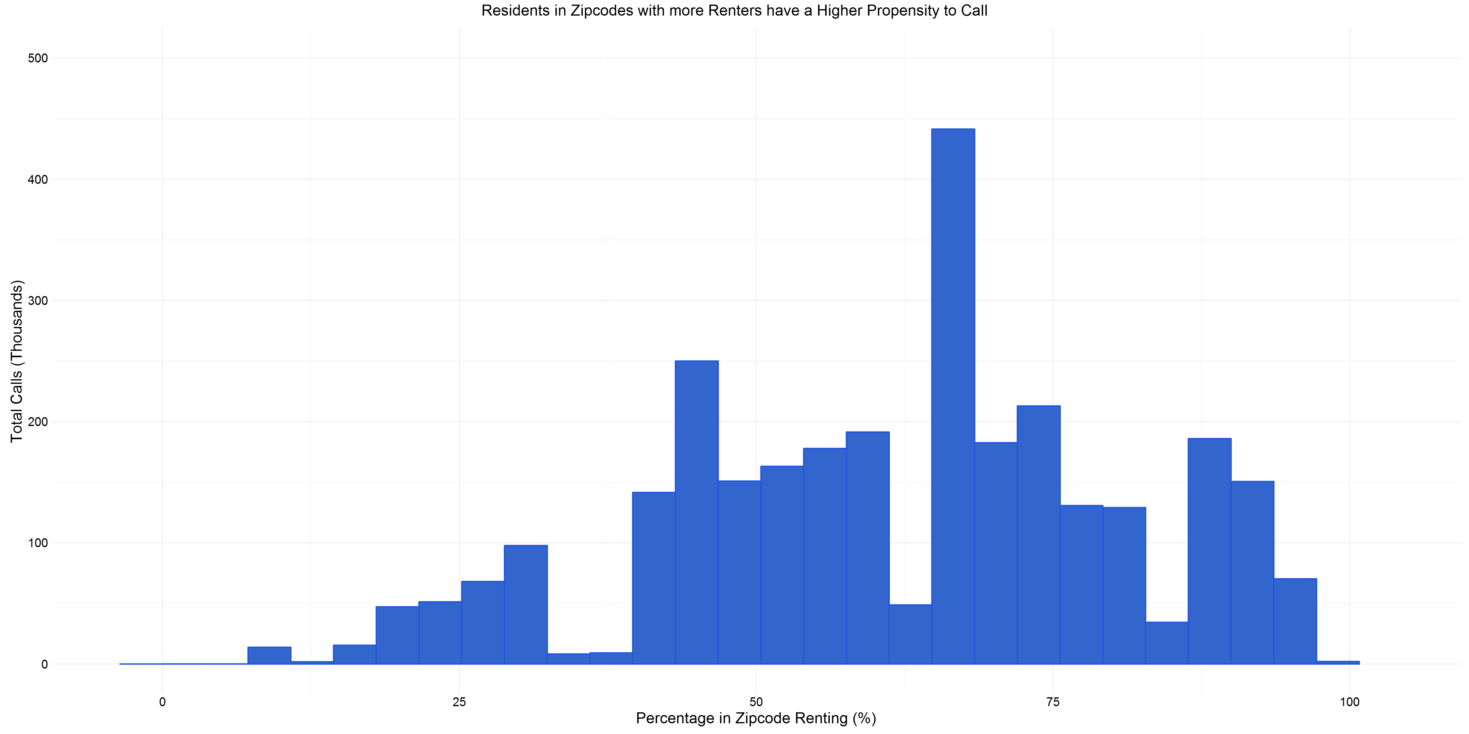

We can see that the majority of calls (about 45%) result in a transfer or referral to another city department.

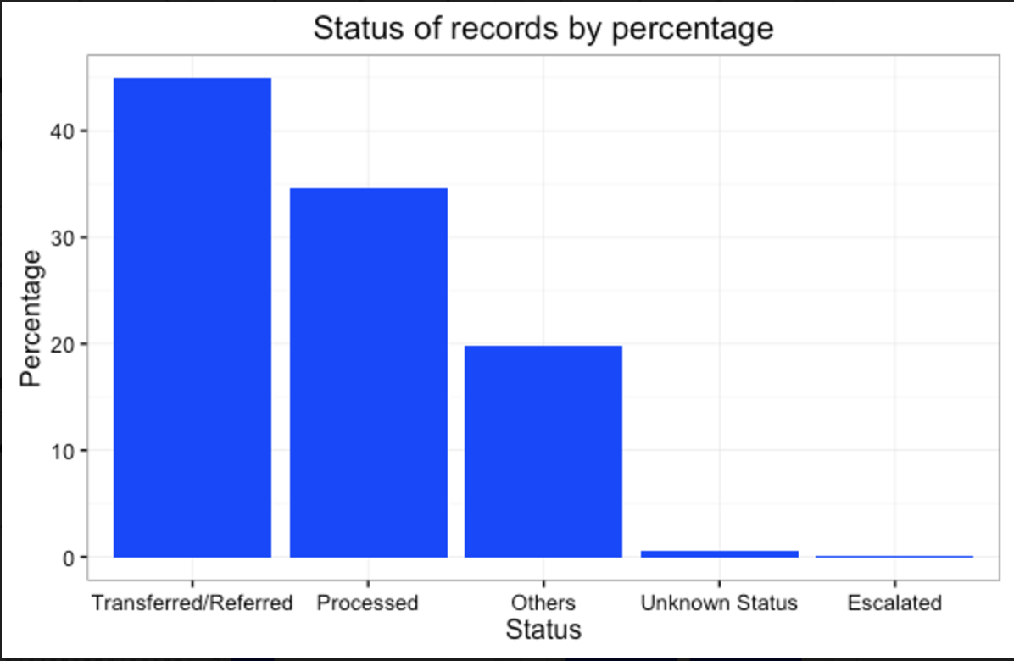

Looking at the status of records from 2011 to 2015, we can observe that the level of processed requests have remained relatively stable while the level of transferred/referred calls fluctuate from year to year—namely in 2011 and 2014.

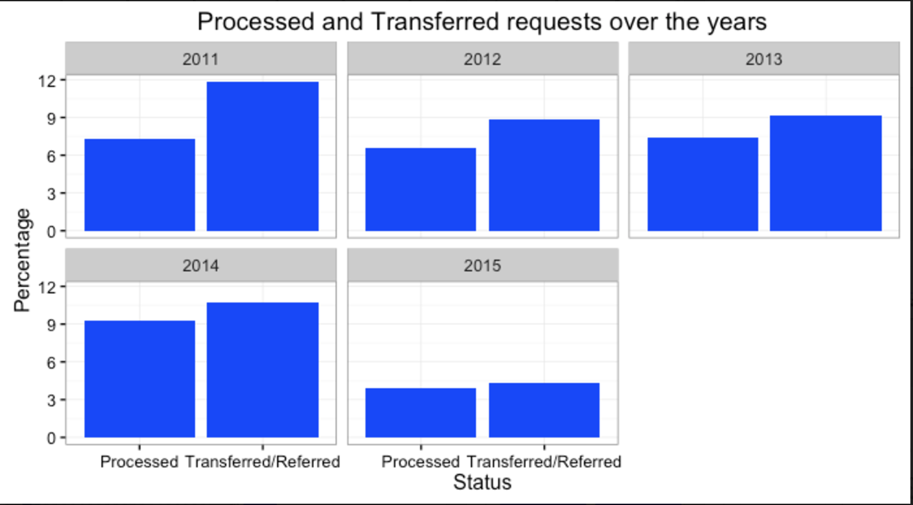

Breaking down the number of requests based on week days and hours of the day, we can see that much of the call activity occur on a Monday and are generally clustered around 10:00AM and 3:00PM throughout the week. The aggregate daily number of calls steadily drops as the week goes on, with the weekend having lowest number of aggregate daily requests.

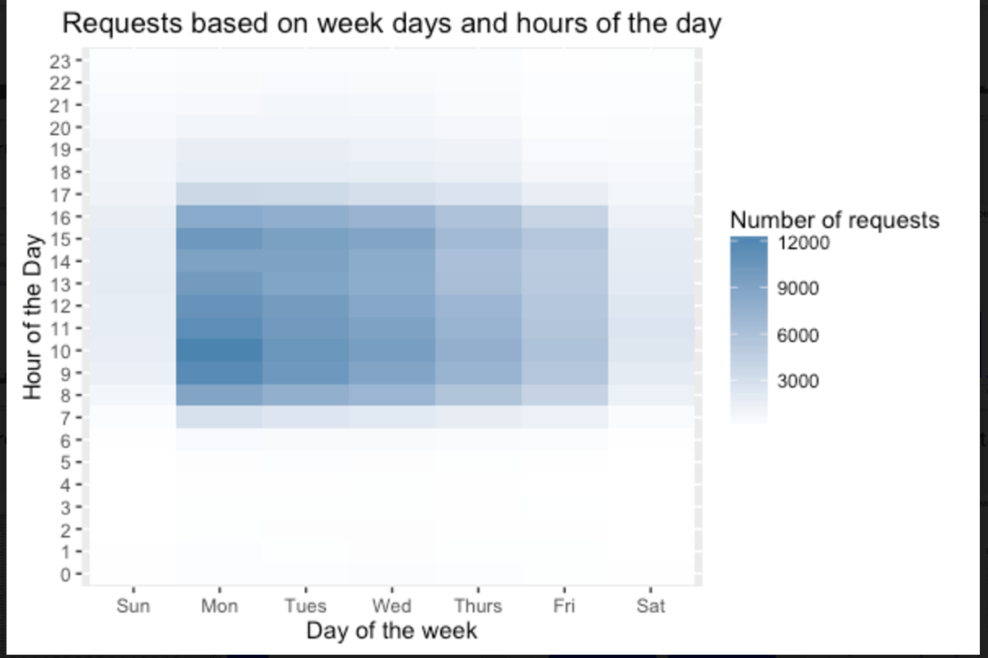

Many of these calls are clustered in the downtown Los Angeles area.

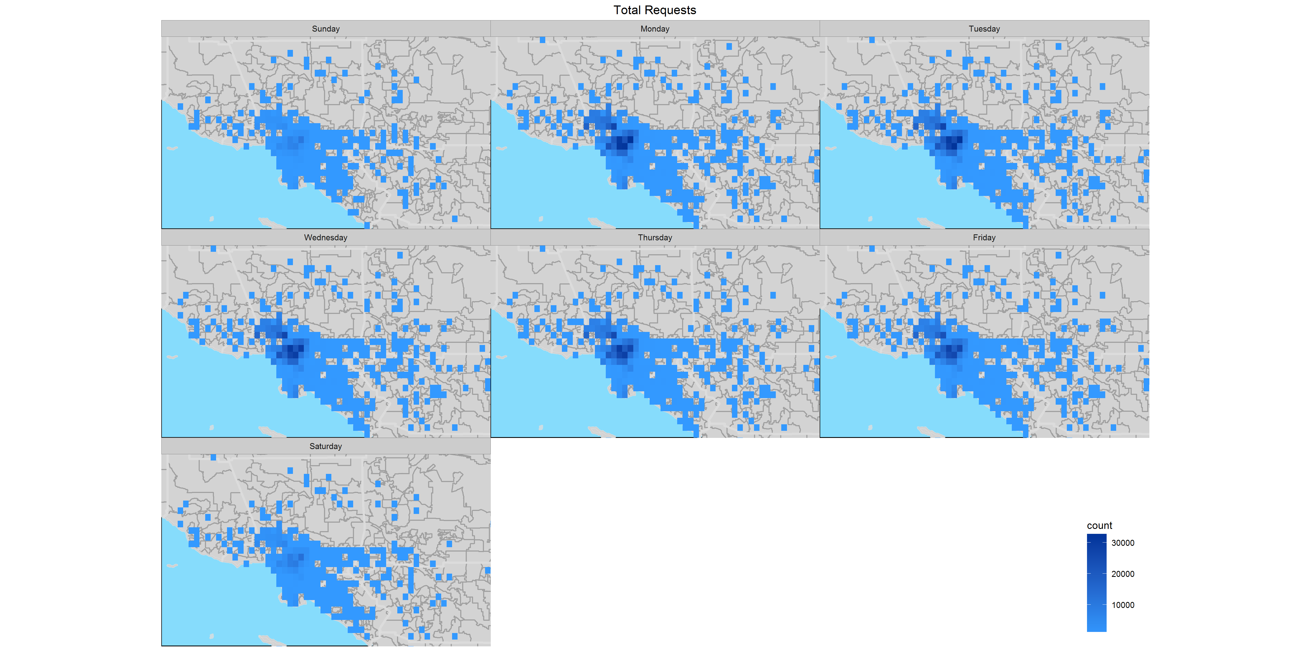

We can observe that the top 3 requests to the system are bulky item pick-up, request for permit inspection, and graffiti removal.

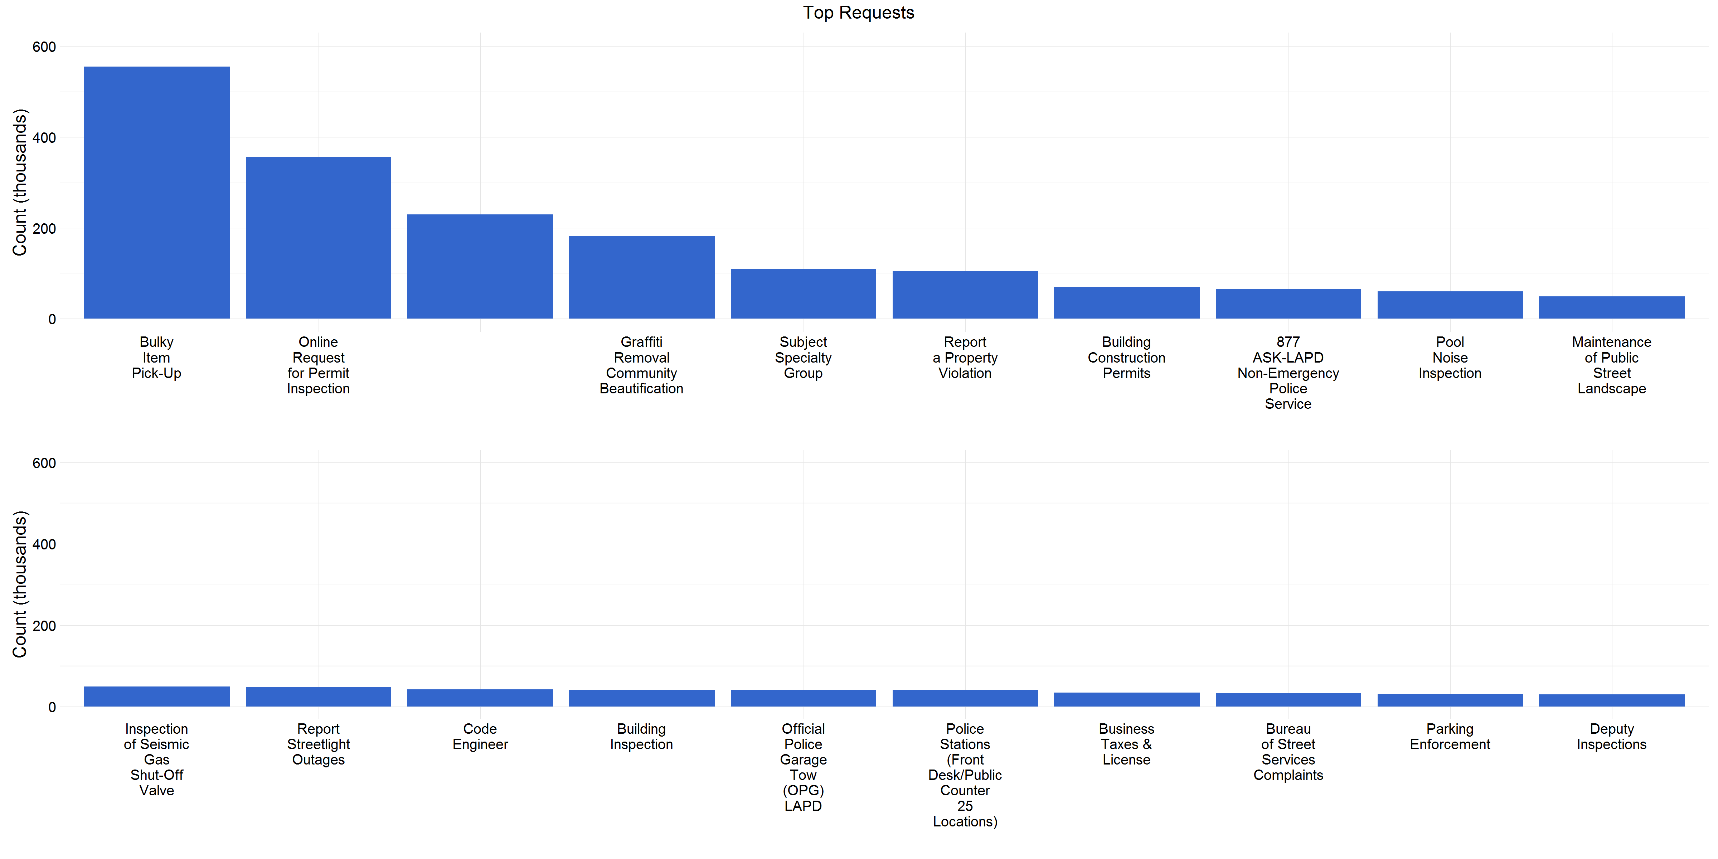

A very high percentage of request types (over 70%) are for the removal of bulky items, metal/household appliances, and electronic waste.

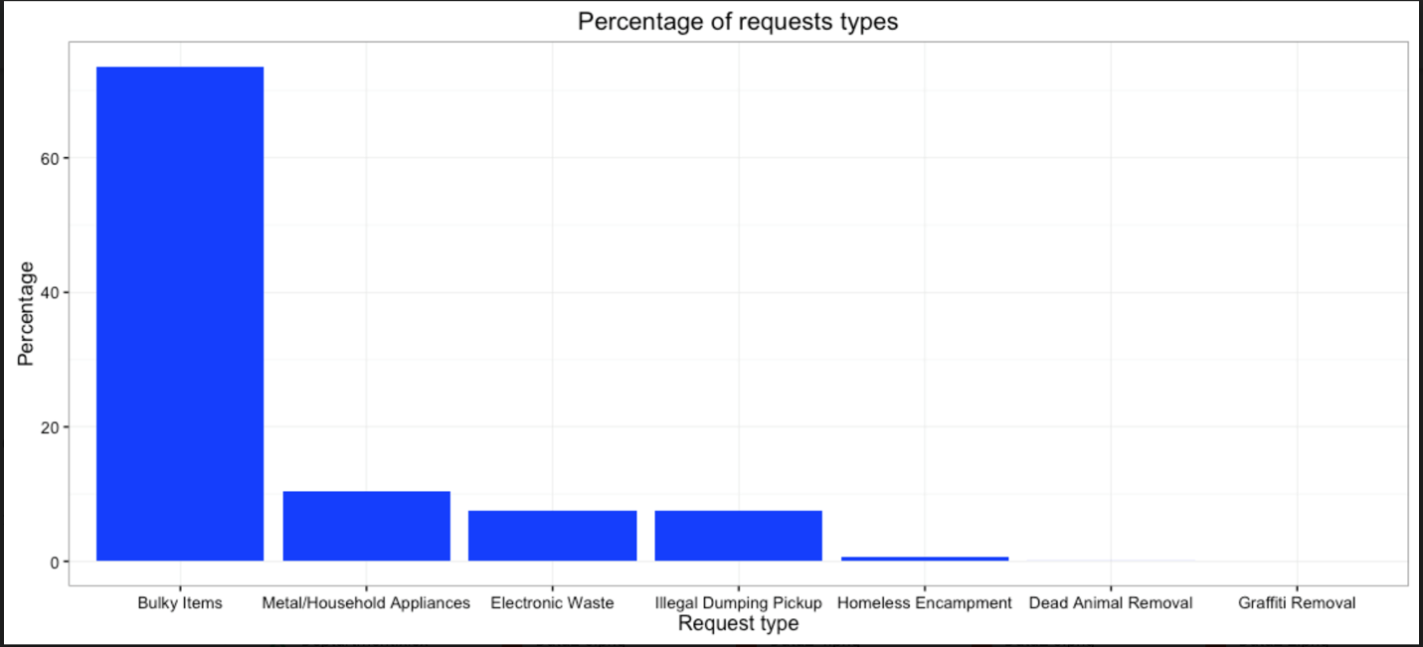

These top request types are generally concentrated around downtown Los Angeles and north of downtown in the San Fernando Valley.

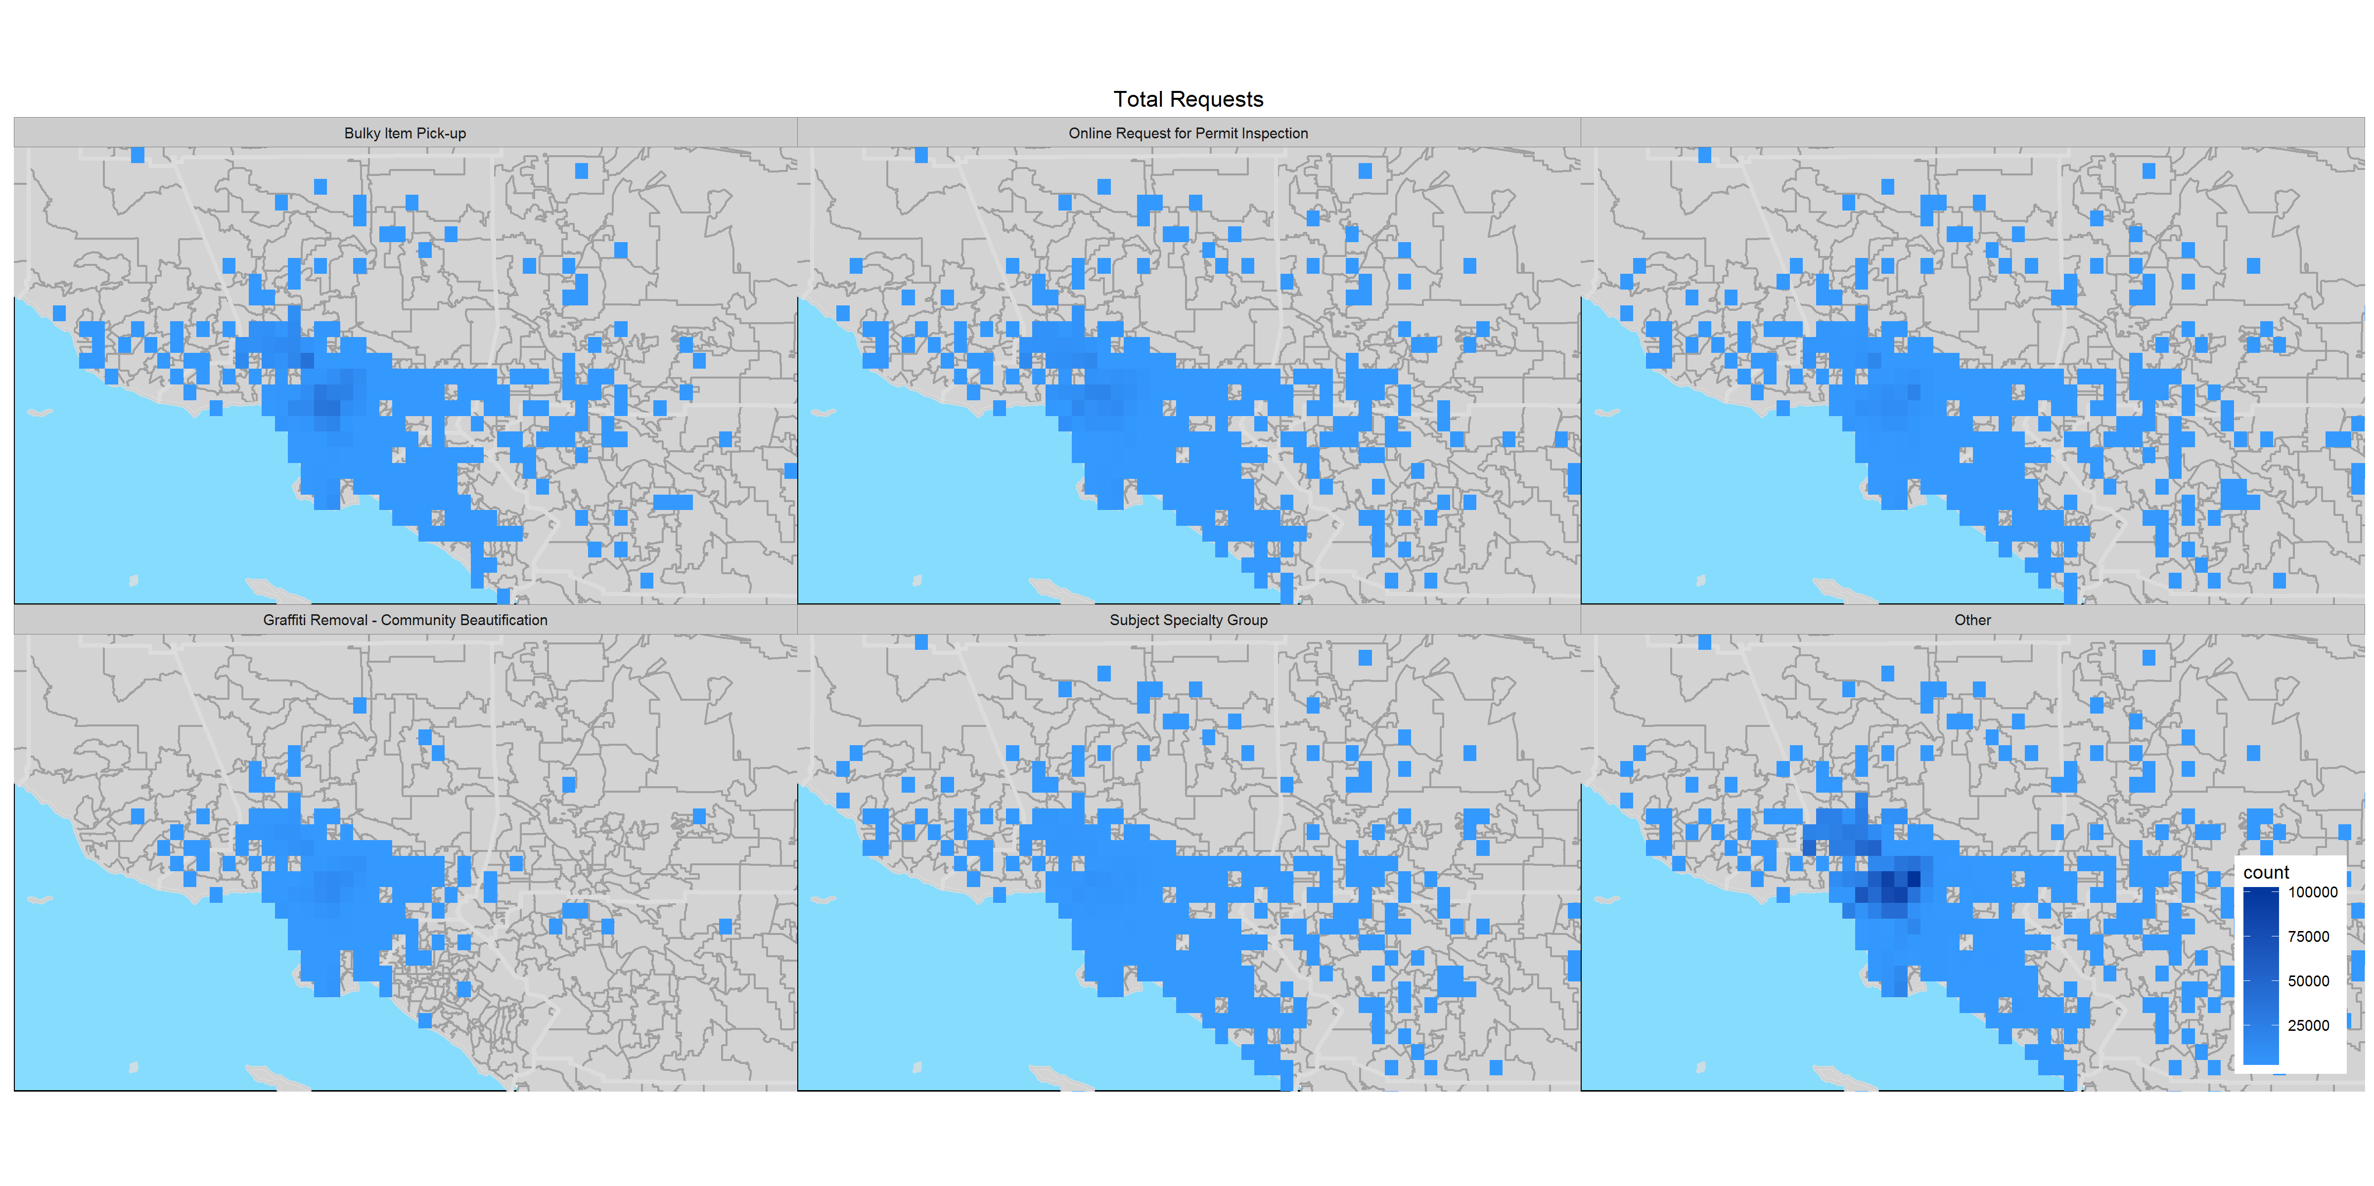

We can see that bulky item, metal/household appliances, illegal dumping pickup peak in the first quarter then drops precipitously in the second quarter before increasing in volume over the remainder of the fiscal year in Q3 and Q4.

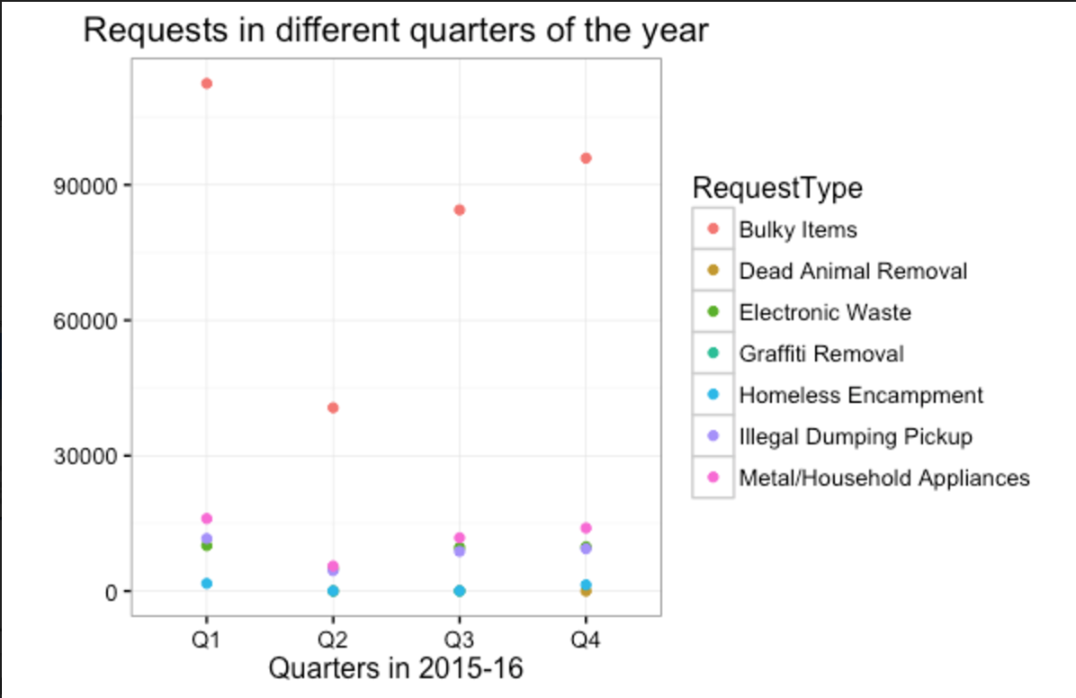

A majority of the requests in 2015 and 2016 come through calls to the 311 phone number, and represent about 80% of the requests. The second frequent source of request originates from mobile apps. We can see the increase in the use of mobile app and self service web portal from 2015 to 2016.

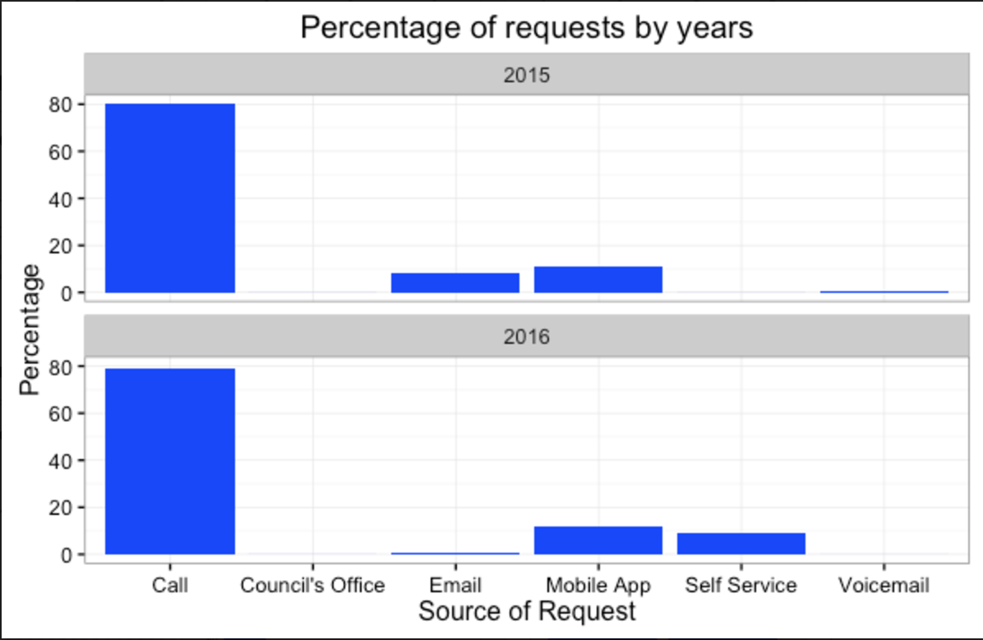

The number of mobile app users are split almost evenly between the two mobile platforms, with requests coming from iOS devices slightly edging out Android devices.

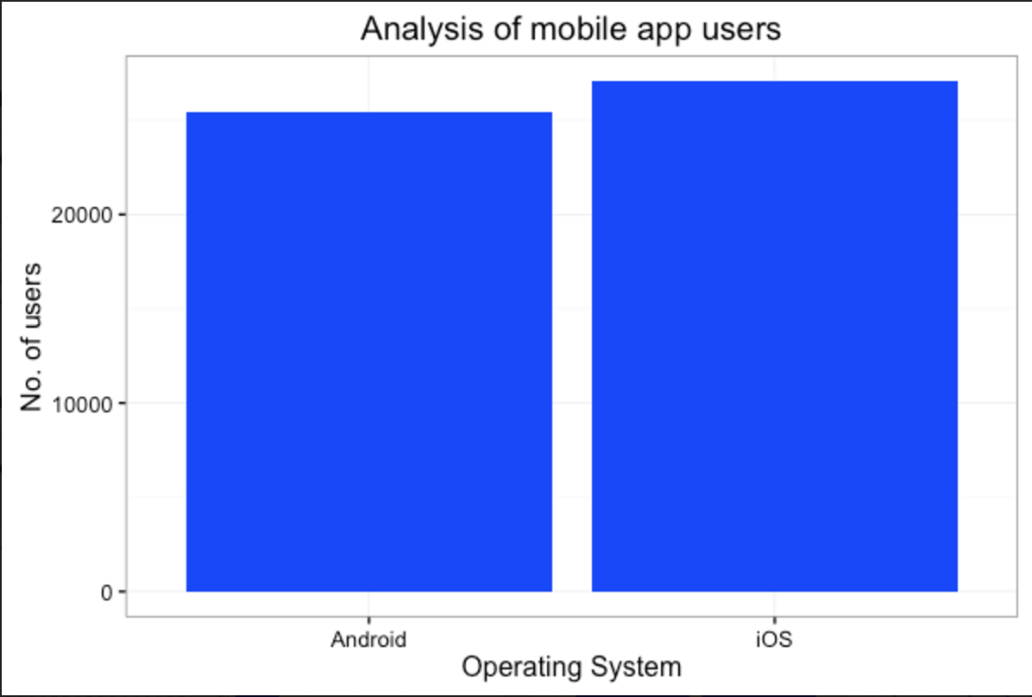

**Conclusions**

After our analysis of the 311 system datasets and combining it with U.S. Census data, we have observed the following key takeaways:

* From a geographical standpoint, the concentration of calls to the 311 system are primarily concentrated in the downtown area and concentrated to a lesser extent in the San Fernando Valley and in the South Bay in the San Pedro/Long Beach area.
* The majority of these callers have a yearly income of approximately $30,000 and $70,000.
* Areas with more senior citizens (over the age of 65) are represented at a higher rate.
* Areas with a higher rate of renters are represented at a higher rate.
* A majority of the calls in the system are for transfers or referrals to other city departments, and occur in the beginning of the week starting on Monday and are concentrated around 10:00AM and 3:00PM.
* Over 70% of service requests are for the removal of bulk items, household appliances, and electronic waste.
* A majority of the requests in 2015 and 2016 come through calls to the 311 phone number, and represent about 80% of the requests. The second frequent source of request originates from mobile apps. We can see the increase in the use of mobile app and self service web portal from 2015 to 2016.

**Recommendations / Future Considerations**

Our recommendations and future consideration for the 311 system can be summarized in three different areas: increasing the robustness of the analytics on existing data, increasing the efficacy and efficiency of city services, and streamlining the requests and responses in the 311 system.

We propose a form data dictionary to allow for improved communication across parties, and the incorporation of predictive modeling for the 311 system database to improve how the department can respond and improve the city’s services. This allows us to use a neighborhood’s characteristics to predict future service requests volumes across the city, and respond appropriately.

By analyzing the location and time concentration of the highest requested services, the removal of bulk items, household appliances, and electronic waste, and can better anticipate and respond to these service requests. Taking bulky items as an example, the city could potentially locate centralized fleet locations to minimize driving time and fuel costs. For electronic waste, the city can potentially determine suitable dates and locations to set up collection points for electronic waste. These events and facilities would be located in areas with high call rates, or set up during or following periods of high call volume. Providing the city’s inhabitants the option to drop off the electronic waste themselves would reduce the overall burden on the city’s electronic waste pickup services.

Since the majority of calls in the call center are for referred and transfer calls, the 311 department could improve the information provided on the self service webpage or mobile app to better redirect a person to the appropriate department and, thus, relieving the 311 call center. Other improvements to the mobile app including user interface streamlining, increase awareness, and providing meaningful and actionable alerts can drive more of the city’s inhabitants to the more automated platform—allowing the city to more efficiently serve the population’s needs.